WEBPAGE FOR PREVENTION OF COVID-19

**Abstract:**

At present we are facing many situations due to Corona virus, which is killing the lives of many people. As there is no vaccine for Corona virus now, we have only one solution suggested by the government, i. e lockdown. In the case of lock down we are facing many situations as everything like shops, groceries, food markets, restaurants are closed. But they permitted some time for most important groceries shops to be open. But we need to maintain social distance to void this.

As it takes more time to get a vaccine many health organizations have suggested that we should be careful, and we should follow self-regulations to be safe. As we can’t live completely in lockdown the government is also suggesting the same thing.

So, after lockdown we should take some measures if any universities open. So, for the safety of students and staff, we had created a webpage which helps us in this difficult situation. Using this webpage, we can get information and health conditions of all the students and staff before and after they enter the collage after lockdown. This helps us a lot, using this information we can take particular measures and we can prevent covid-19. Cleanliness is also the best prevention of this harmful virus. So, in this app we can maintain cleanliness of universities and make them hygiene.

So, using this webpage helps us to prevent covid-19 in the university by collecting information from the university visitors.

**Objective and Motivation:**

The main objective of our project is to know about the covid-19 and what are the precautions to be taken. It explains about the corona virus, and the main aim of our project is, it can actually create awareness for students who are not taking care of themselves on Covid-19. Also, our website provides a complete webpage where you can find many links and information about prevention of covid-19. Our website gives measures to protect yourself and others from this deadly virus.

The present situation of covid-19 is rapidly increasing across the world. The United States of America, Italy and Spain are the countries which are highly affected by the virus. To get more awareness in the people the Indian government has released an app called “Arogya setu”. In this app it will get an alerted if someone you have come in close proximity of, even unknowingly, tests covid-19 positive. In the same way we have designed a webpage. In the webpage we the admin can know how many people are affected by the virus in the university and also, he can take certain precautions to keep the students and staff safe from who are affected. We can know the status of students or staff like how many are cured, how many active cases are there at present etc. Its alerts are accompanied by instructions on how to self-isolate and what to do in case you develop symptoms that to do in case you develop symptoms that may need help and support. The present situation in INDIA is getting too worse day by day there are many new cases being noted day by day.

So, if the admin get’s the information from the users in the university he/she can take immediate action and make the people alert by knowing the situation of the university.

**Work Flow:**

Here we had designed a webpage which displays a brief information about the university, the events conducted by the university and some precautions (videos, images etc.). If the user registers or login once, it will redirect to a new webpage with the additional features containing room services, covid-19 form, hospital appointment and logout. The user can select anyone of these and use these. If user selects room service, he will be asked to give an input with his/her details and room service options. Similarly, in covid-19 form user gives his input regarding the symptoms and other information like location of the house etc as shown in the below figure. In the same way he/she can book a hospital appointment at the university by giving the reason for check-up and select their time of appointment as shown in below figure. After he can logout and exit from the page. The user input data will all be stored in the database of admin and he can review them and take some actions.

Here we have mainly two options. A normal viewer or user can see the updates of the university. For the university students and staff, we have a register and login option, such that the page can be private to the university students or staff. Here we used mainly two frames.

Pages in this webpage are:

1. Home : start.html
2. Precautions : precautions.html
3. Events : events.html
4. Room services : roomform.html, roomfom.php
5. Covid-19 form : covid-19.html, covid.php
6. Hospital Appointment : hospitalappointment.html, hsp.php
7. About : abt.html
8. Login : login.html, validation.php
9. Register : registration.html, register.php
10. Logout : logout.php

**Flow diagram of transmission of pages:**

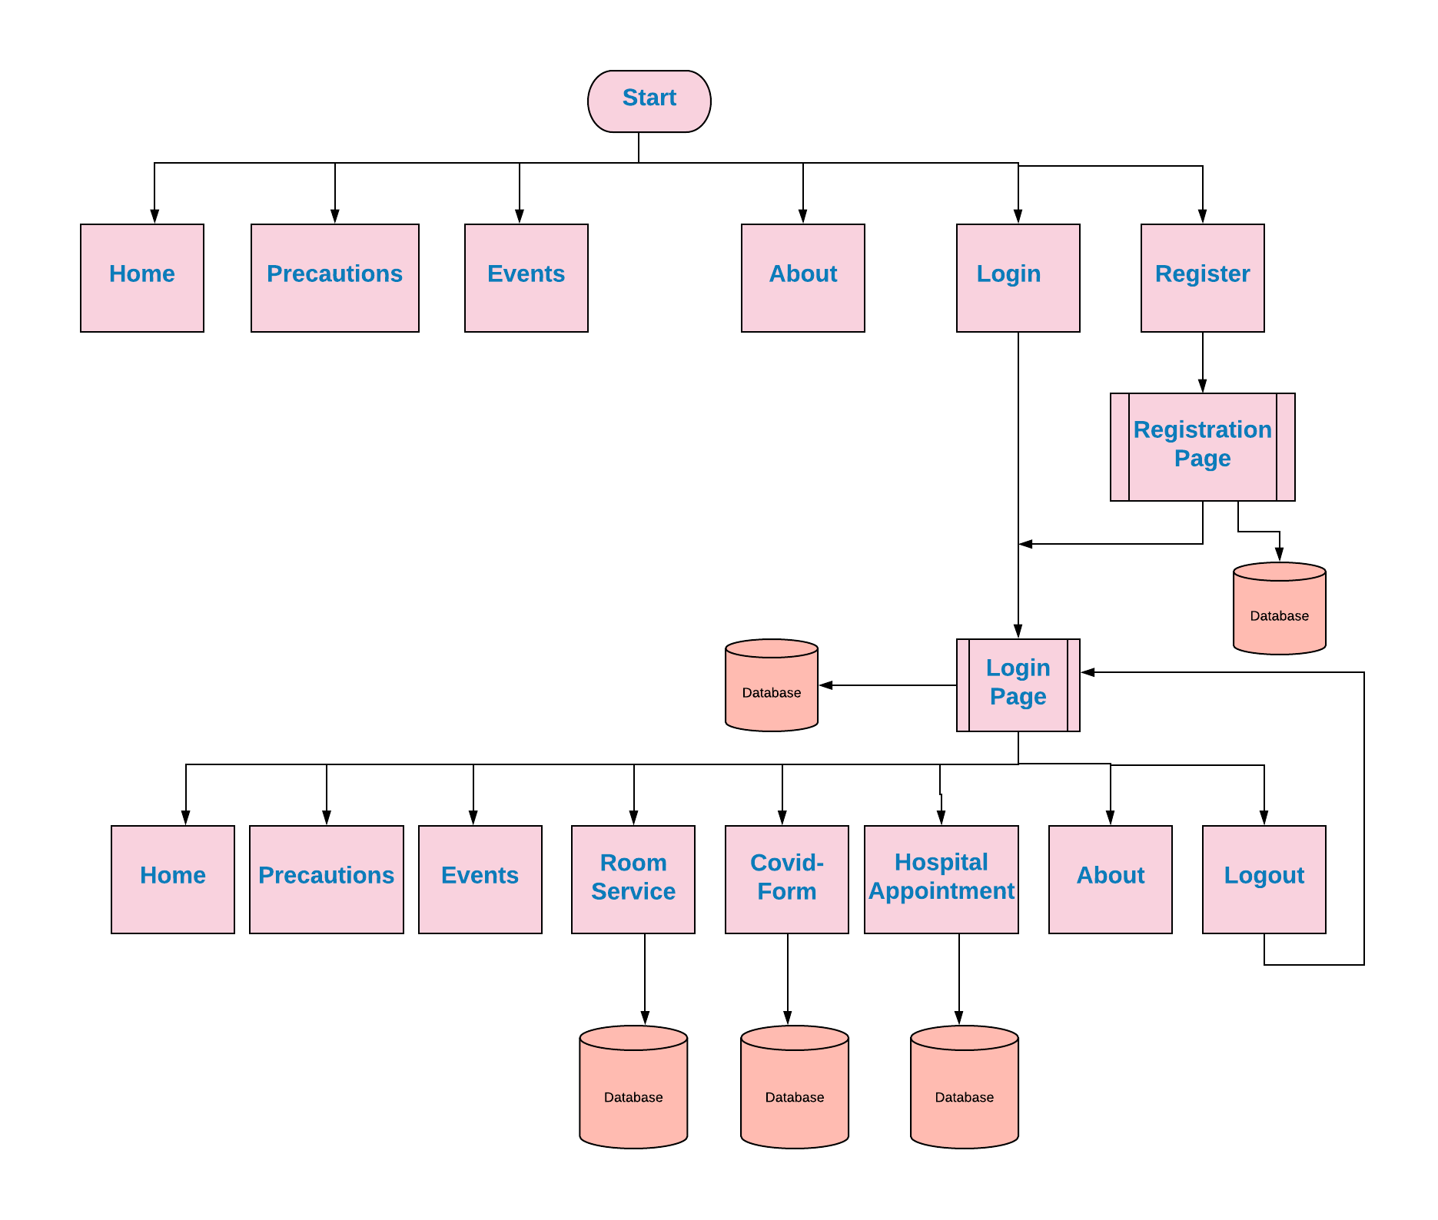

**Screenshots of the pages:**

**Opening page:**

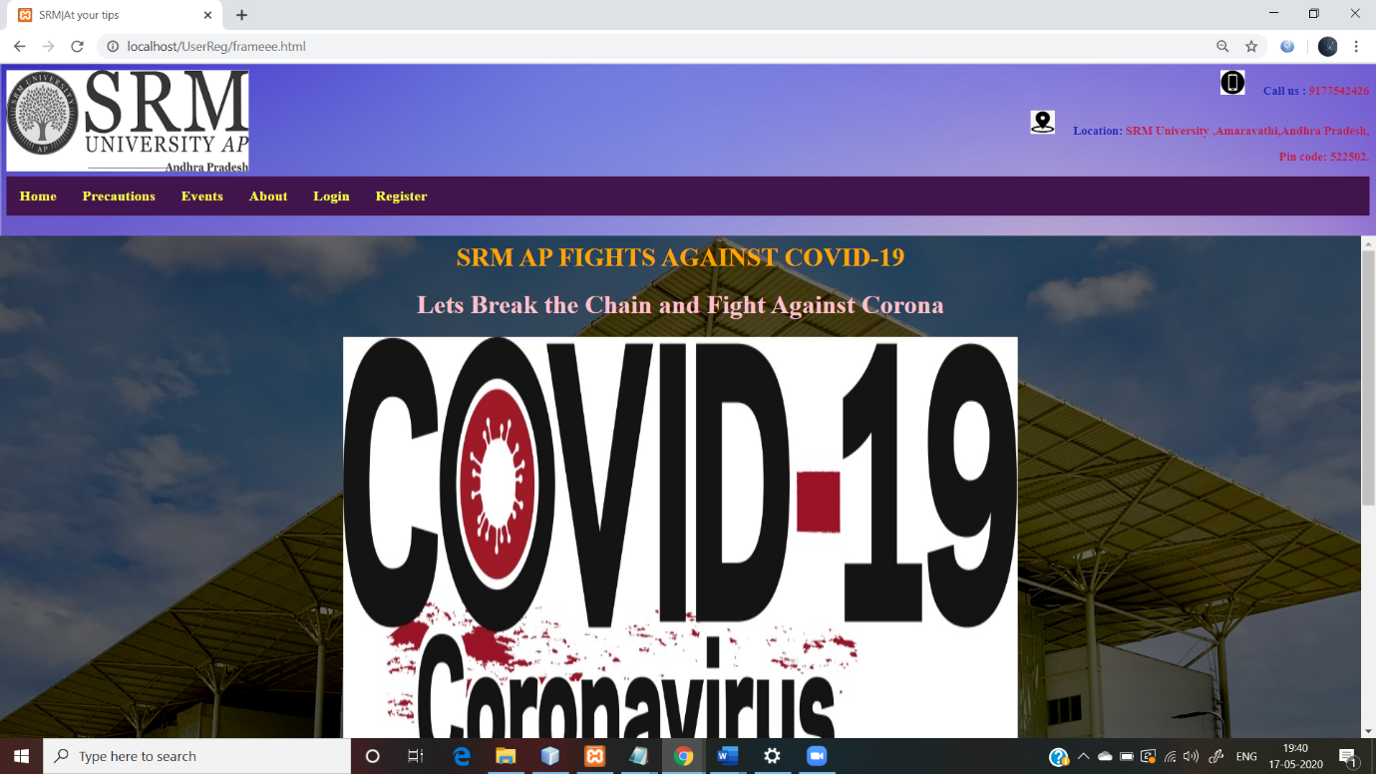

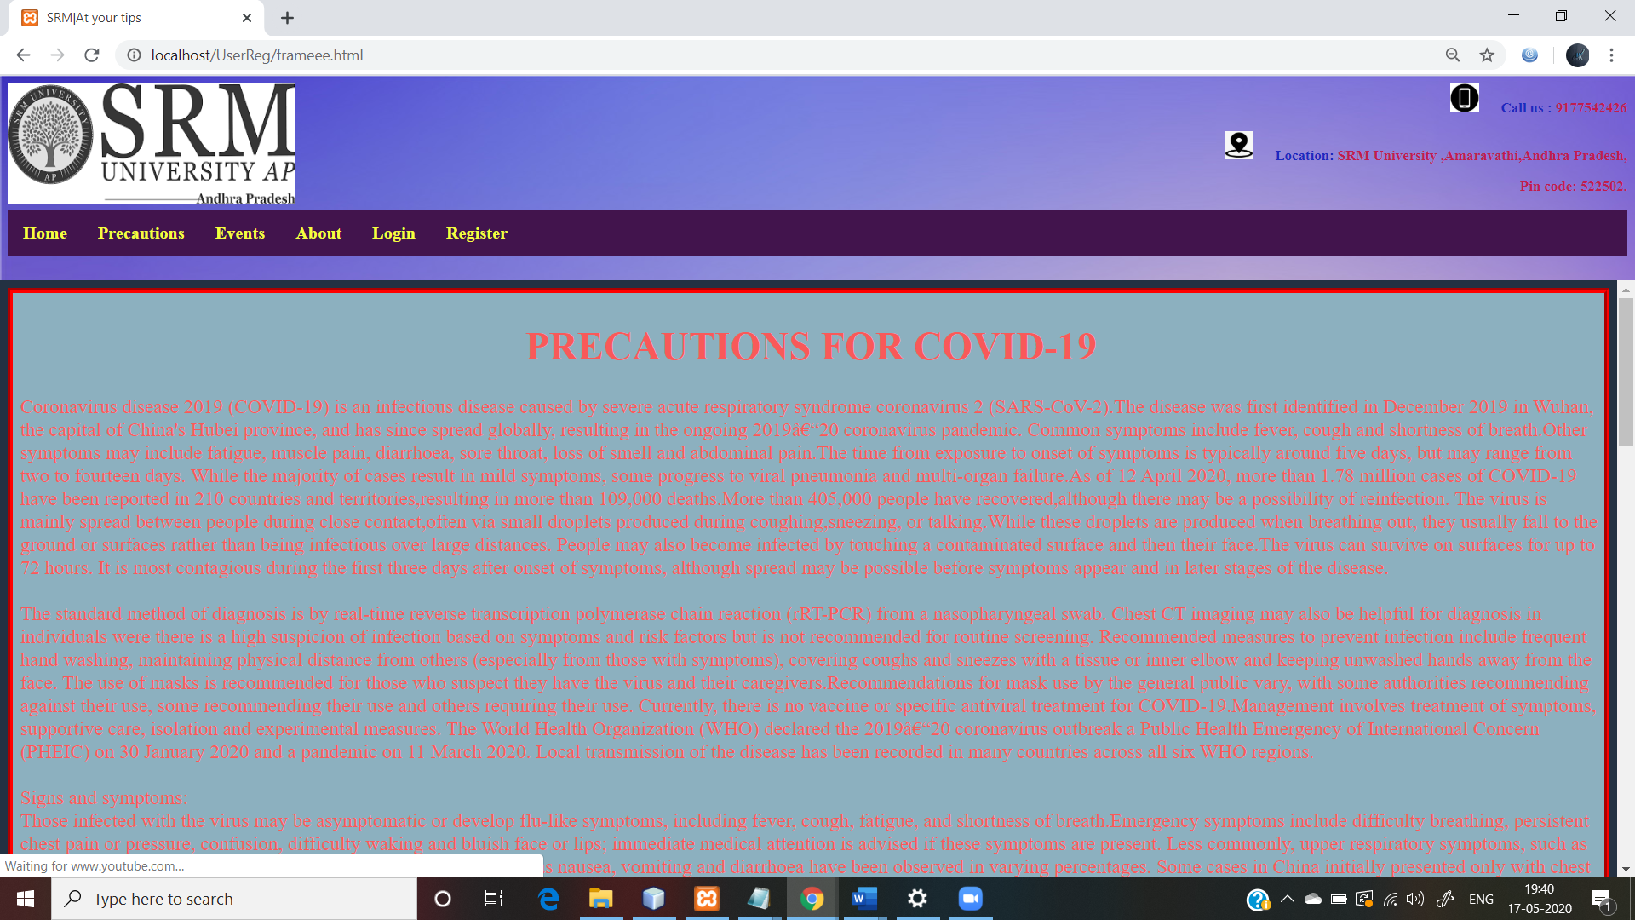**Click on Precautions page:**

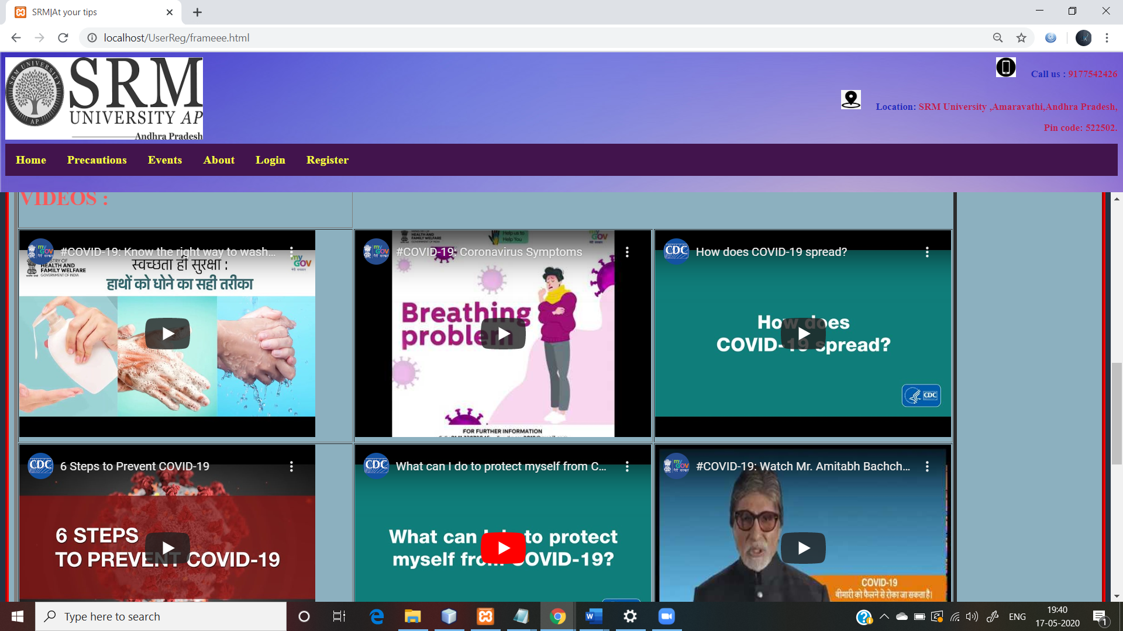**Precautions page:**

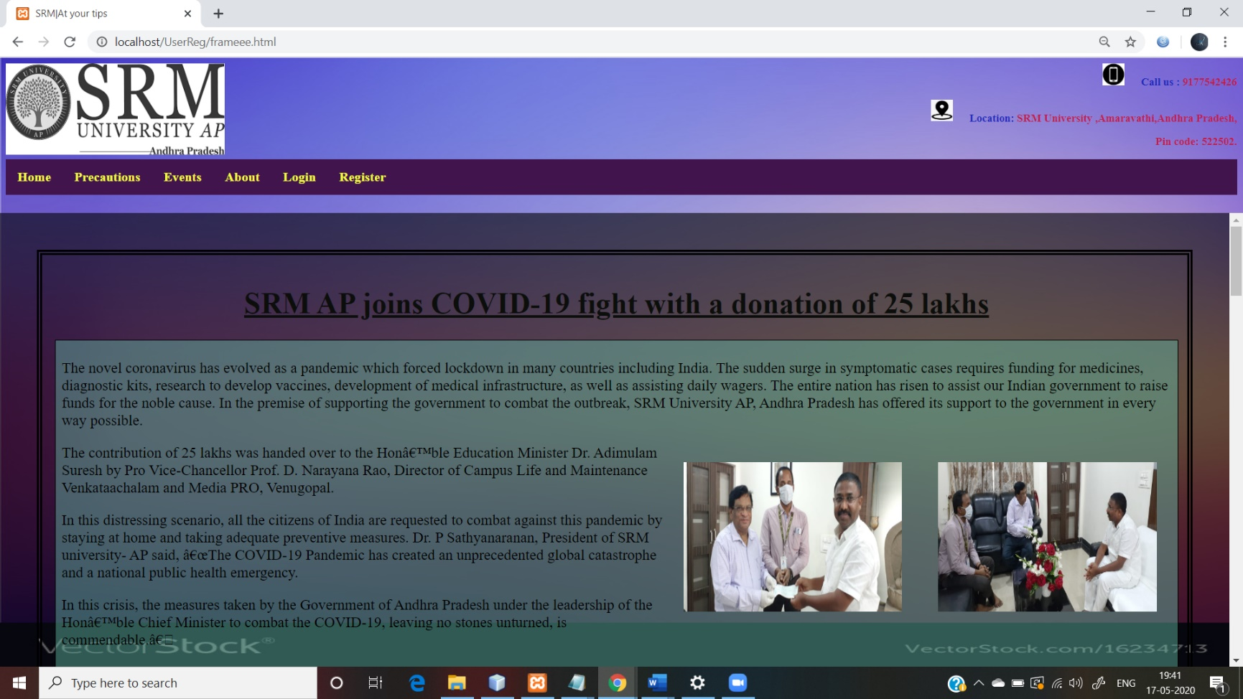**Click on Events Page:**

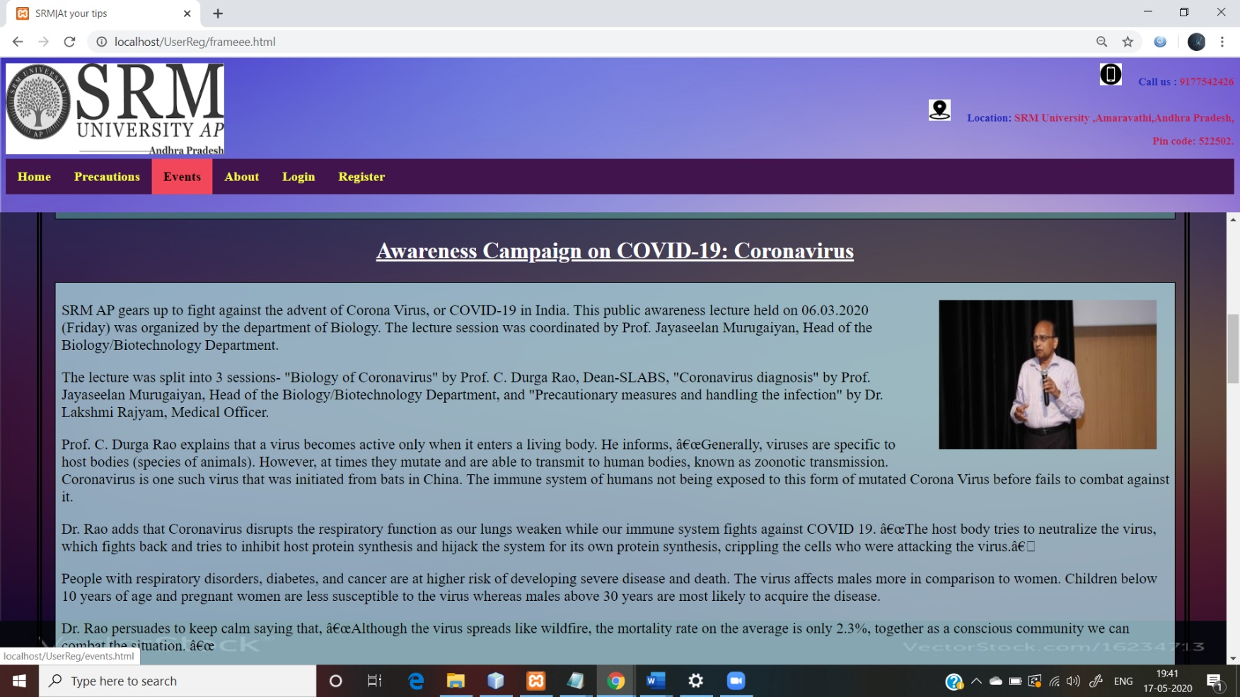

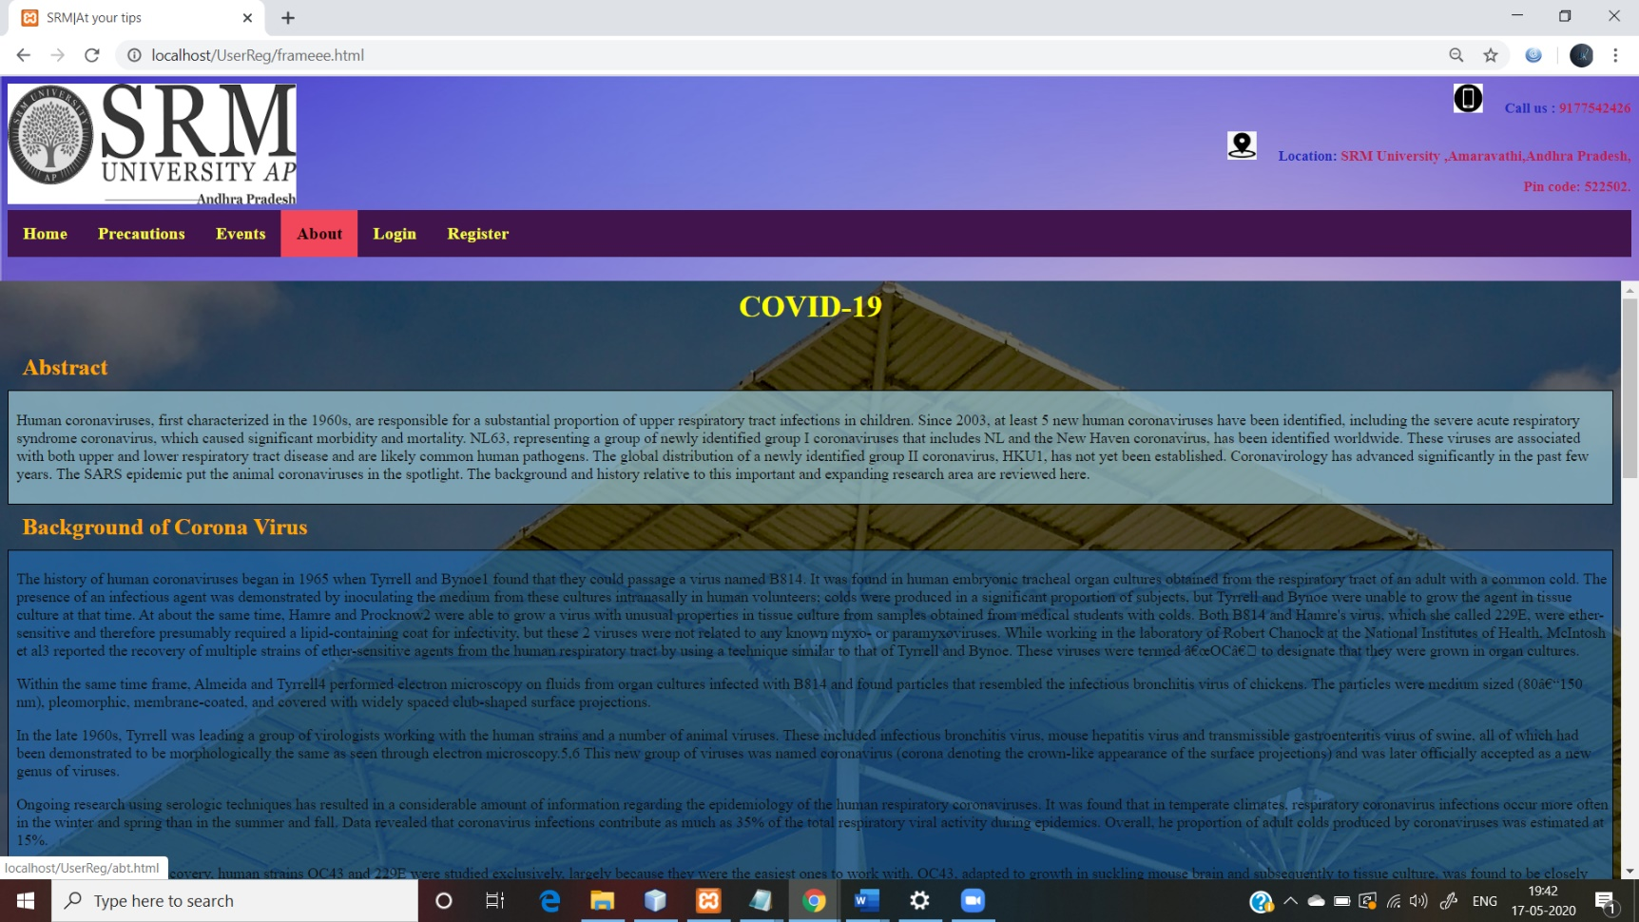**Click on About:**

**Click on Register:**

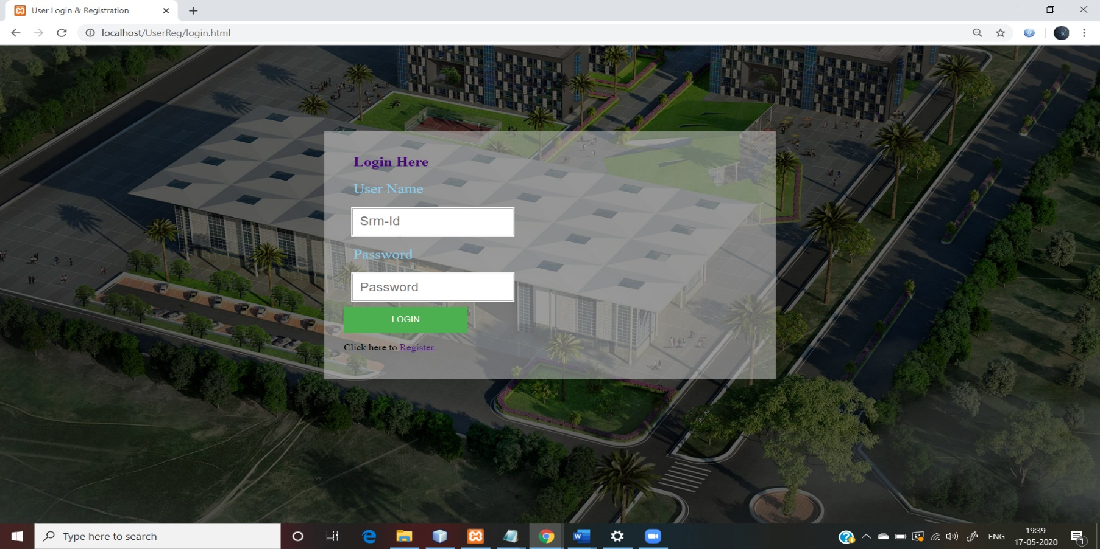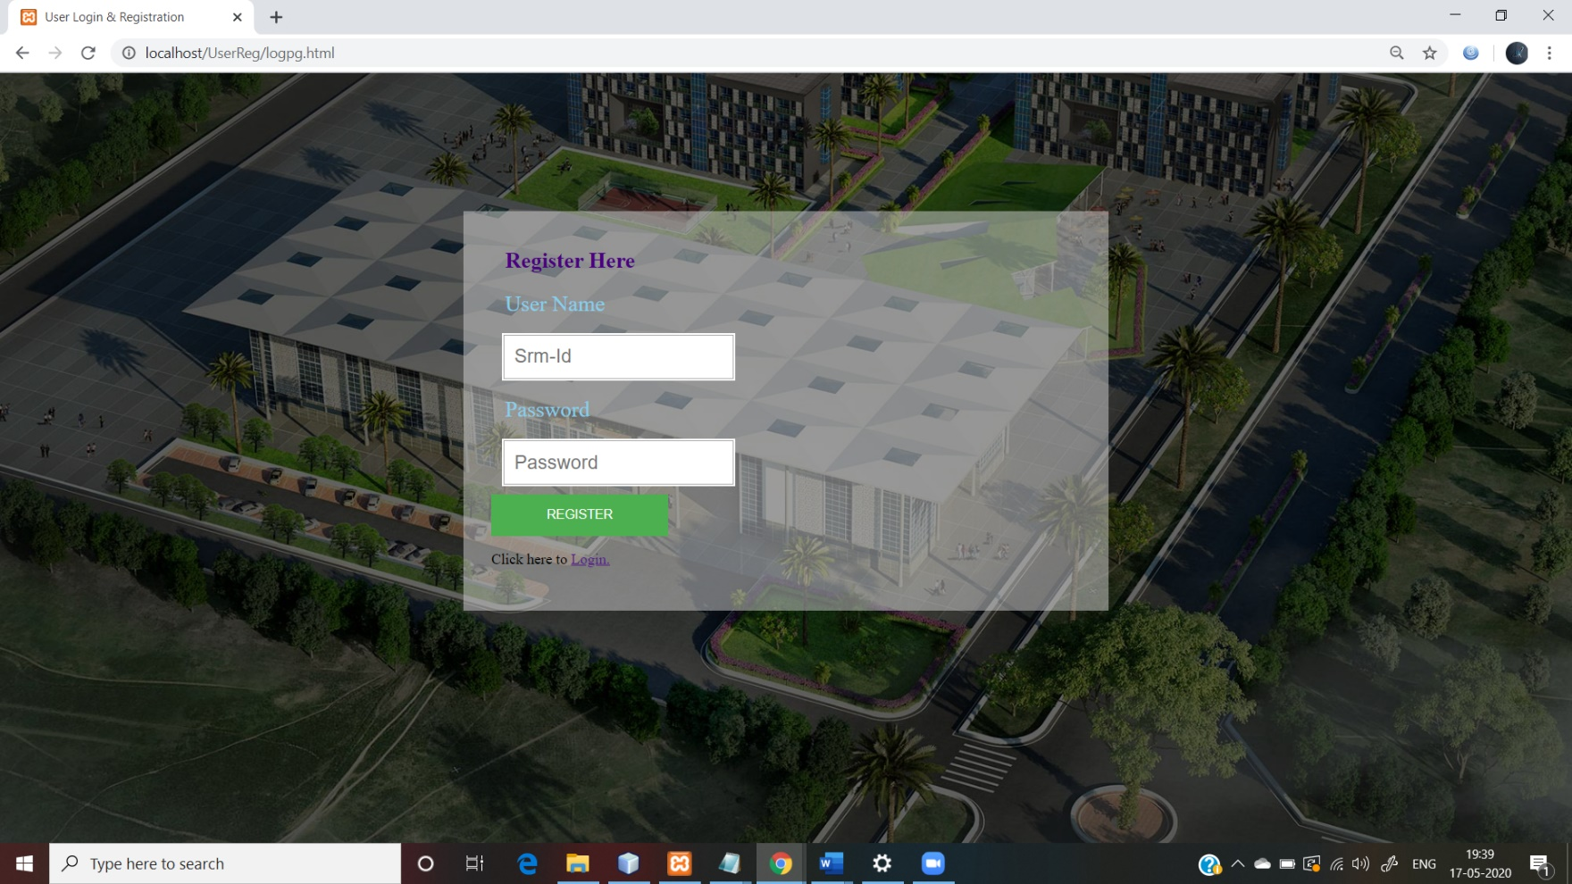**After registering:**

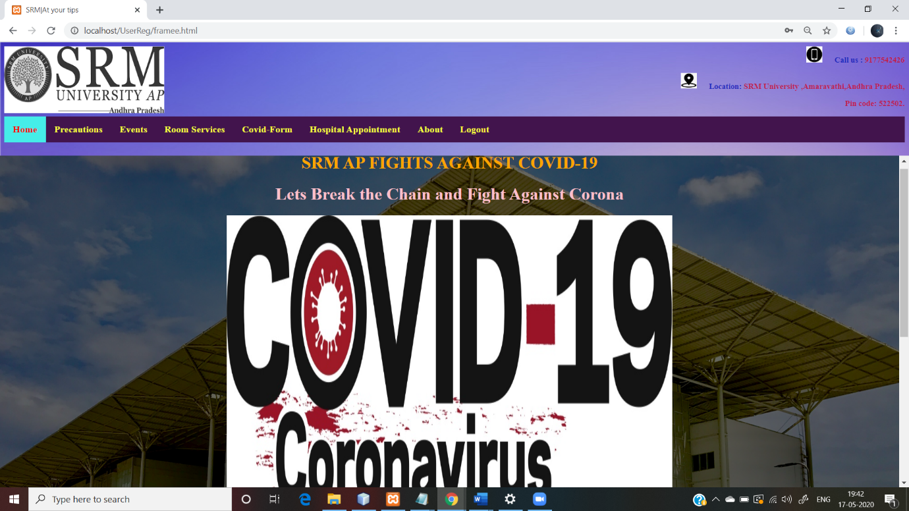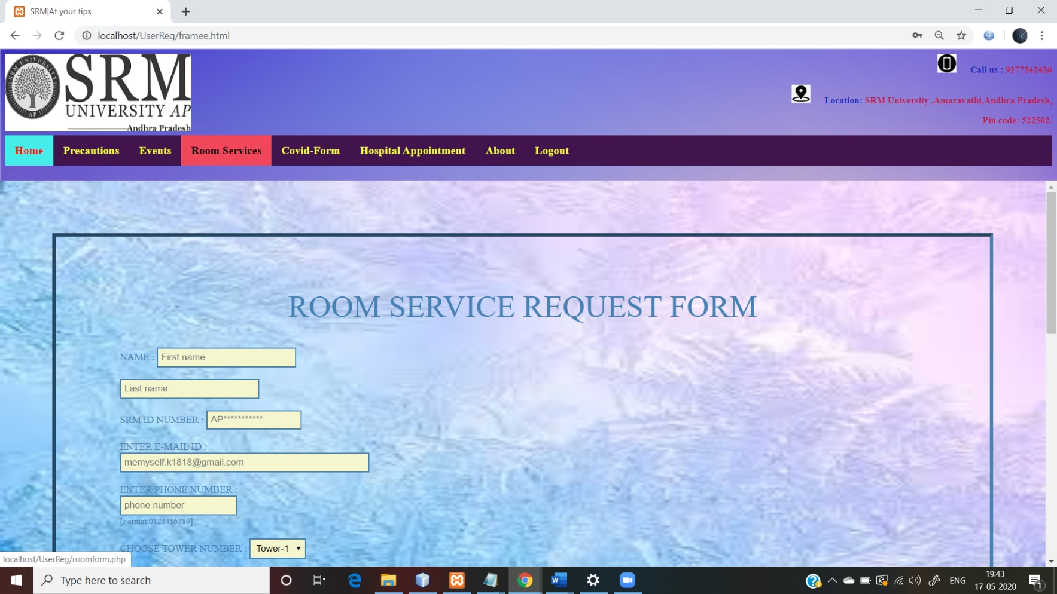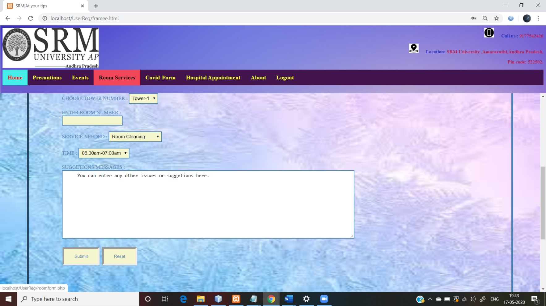 **Click on Room services:**

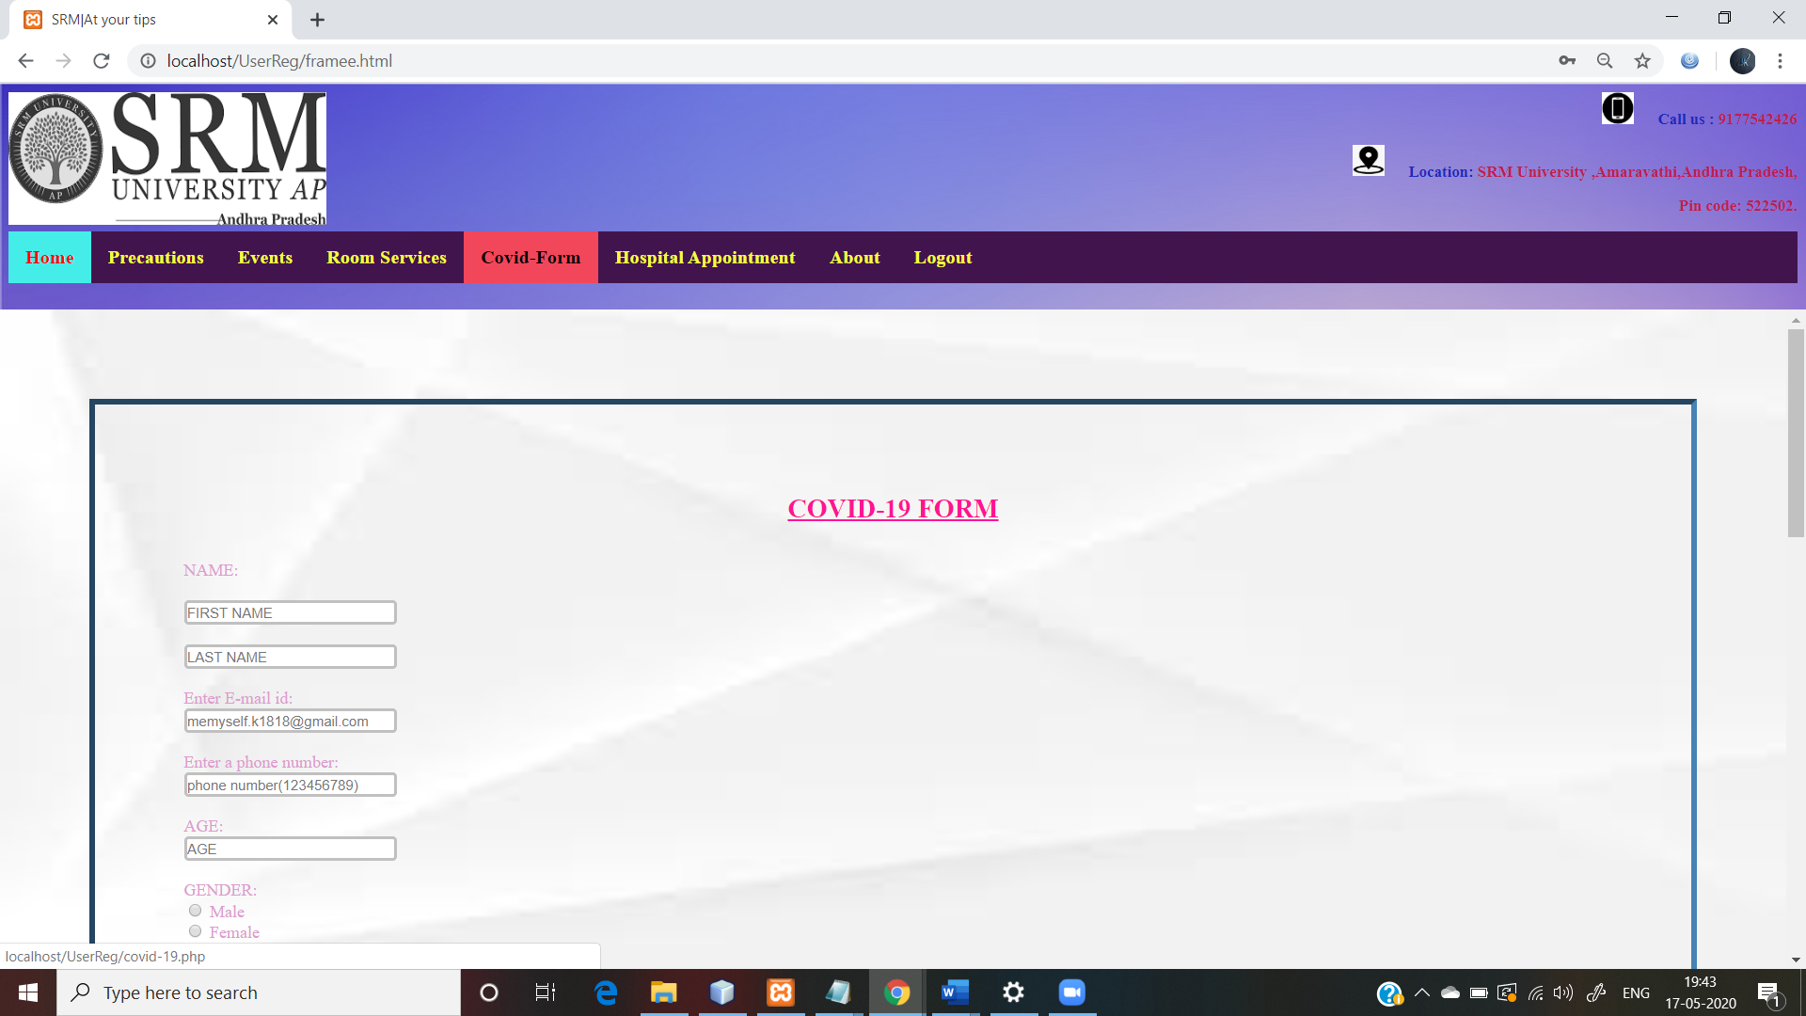

**Click on Covid-form:**

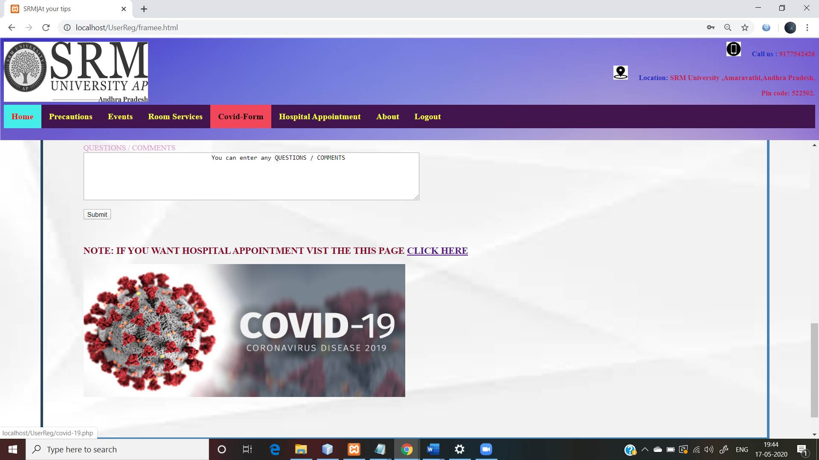

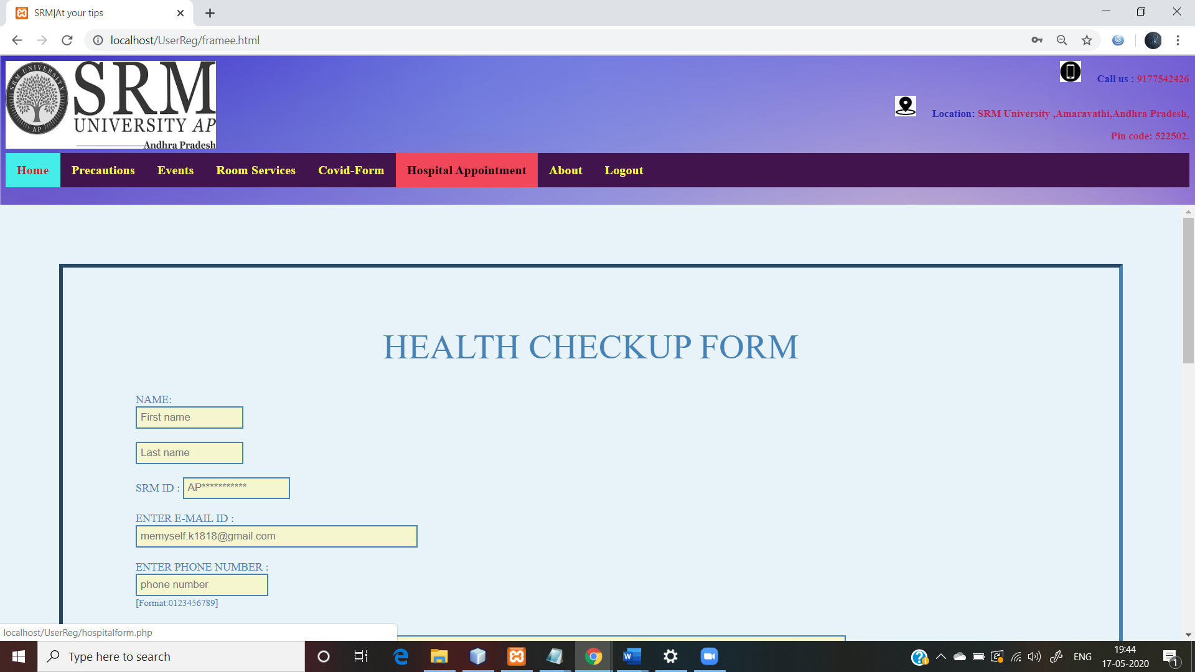

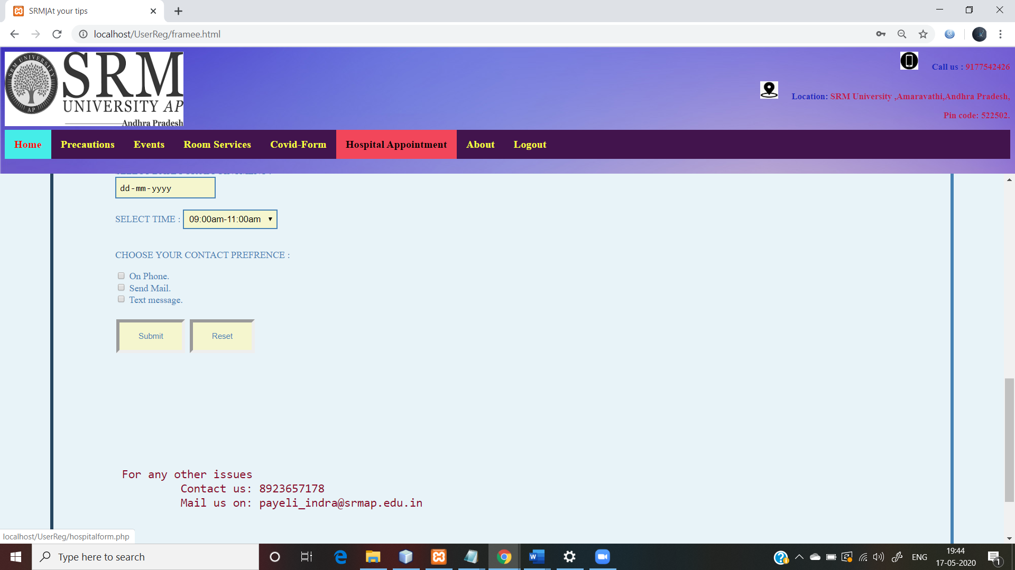

**Click on Logout:**

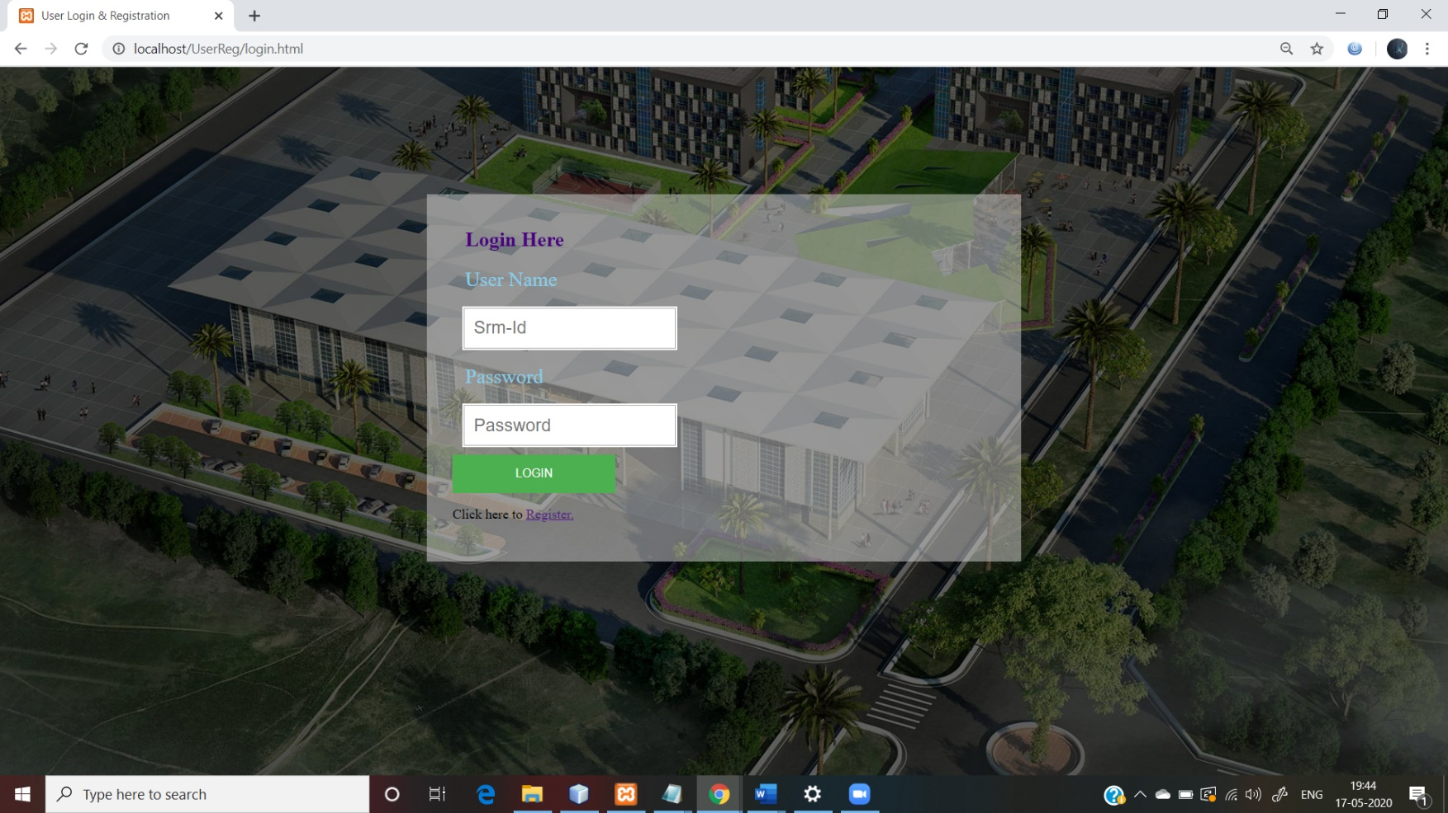

**Database:**

Here the background data is stored in the database. In this webpage we need to have different databases as it completely depends on database. So here we used php and MySQL to manage the database. We had created database for registration, covid-19 form, room service, hospital form. The input given by the user will be stored in these databases. And for login also we had used the registration database to check if the entered details of the user are matching or not. So, to check these we had used php and MySQL as background languages.

**Sample Database screenshots:**

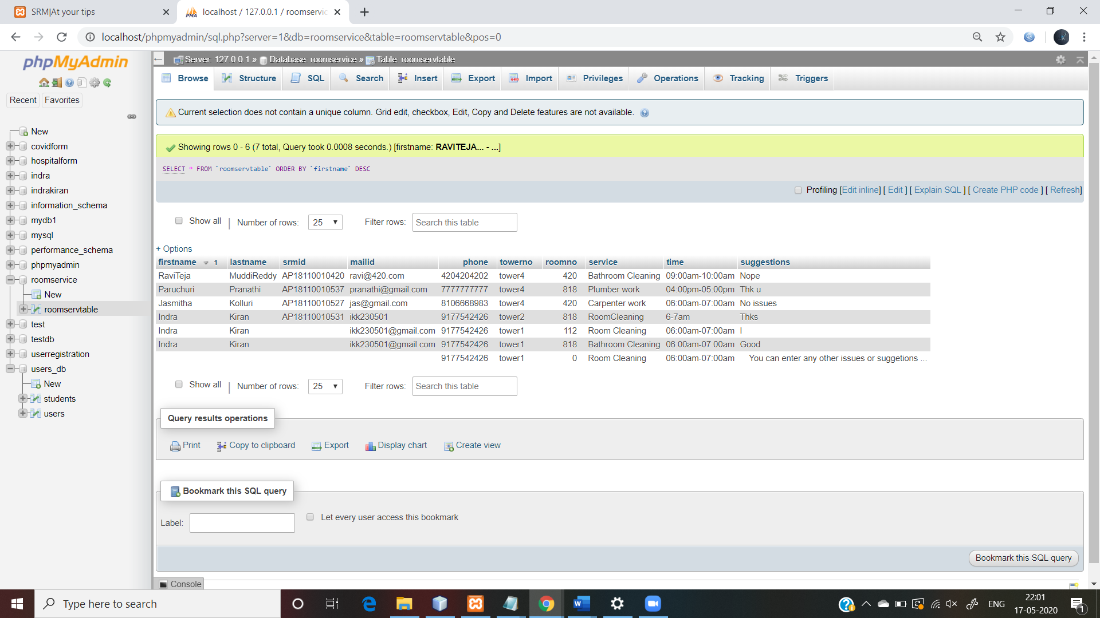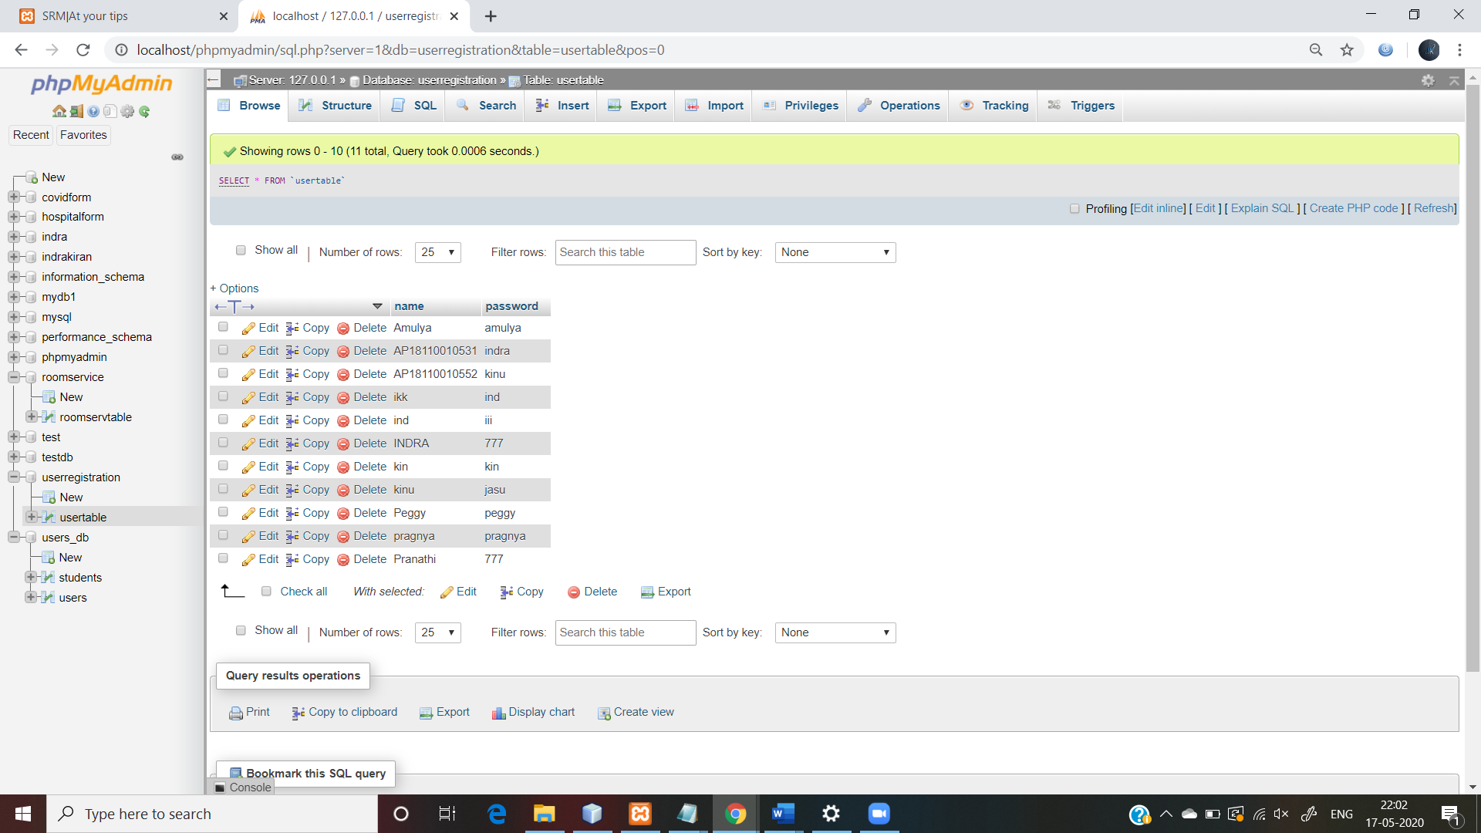

**Technologies used:**

|  |  |
| --- | --- |
| **TOOLS USED** | Notepad |
| **OPERATING SYSTEM** | WINDOWS 10 |
| **SERVER SIDE** | PHP-MyAdmin, XAMPP, Jsp |
| **CLIENT SIDE** | HTML, CSS |
| **SERVICES** | Local host |
| **DATABASE** | MYSQL |

**Goals and future scope:**

Still we need to add some more features for this webpage as it is incomplete without location. We need to add a new feature which finds the location of the student/staff, this helps for security purpose. We also need to add a separate login options for dayschlor’s and hostellers such that it will be easy for the management to differentiate them. And also, we need to add a new feature about mess review, which plays important for the hostellers. We also need to add a separate suggestions page such that university management can look at them clearly. Its also good to add a profile page for the logged in student/staff, such that then can view their progress till now.

So, if these changes are done it will be really more attractive and it looks good.

**Conclusion:**

After College re-open if any of the students suspect that he/she is unwell and are in thought of taking to covid-19 test. They can confirm it by taking Covid-19 survey provided by our website and then make further decisions on visiting doctor.

This website provides Room service and Hospital appointment form which is helpful for hostel students even in normal days. This webpage makes it easier students to make appointments with Doctor when they needed instead of visiting. Hospital filling form and waiting for long hours to make an appointment they can fill their form whenever and wherever they are and the other form help in informing things that are to be cleaned or fixed in their rooms.

There is an Events page this page provides information about the events held by (our college) SRM UNIVERSITY. Through this project we can say that we learned some new topics i. e, database connection through php and MySQL and also improve our webpage Styling skills.